Project Name: AMAZON

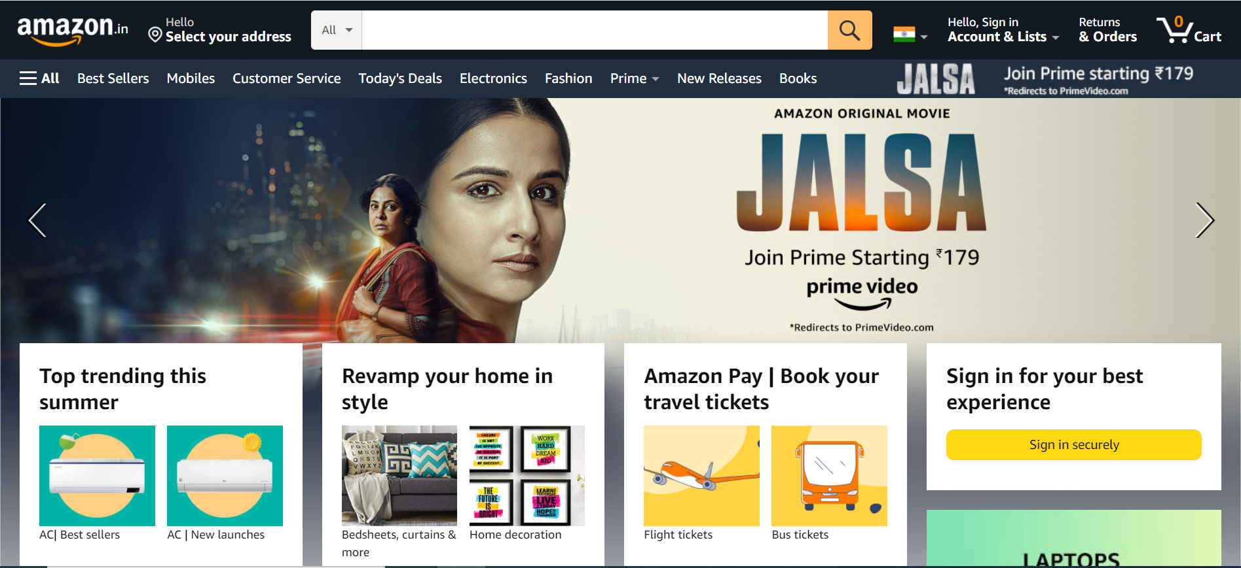

**Overview:** Amazon is an American multinational technology company which focuses on e-commerce, cloud computing, digital streaming, and artificial intelligence. It has been referred to as "one of the most influential economic and cultural forces in the world", and is one of the world's most valuable brands.

**Pages:**

* Login /Sign up page
* Home page
* Product page
* Buying options/Payment gate way.

**Page Structure:**

**Login Page:**

Just like a usual login page, It asks user to enter login id and password.

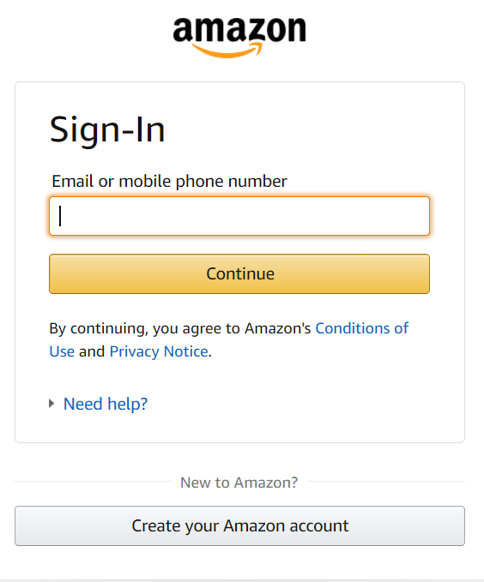

**Home Page:** Itcontains

* LOGO



* SELECT YOUR LOCATION



* SEARCH BAR



* ICONS (WISHLIST, ADD TO CART)

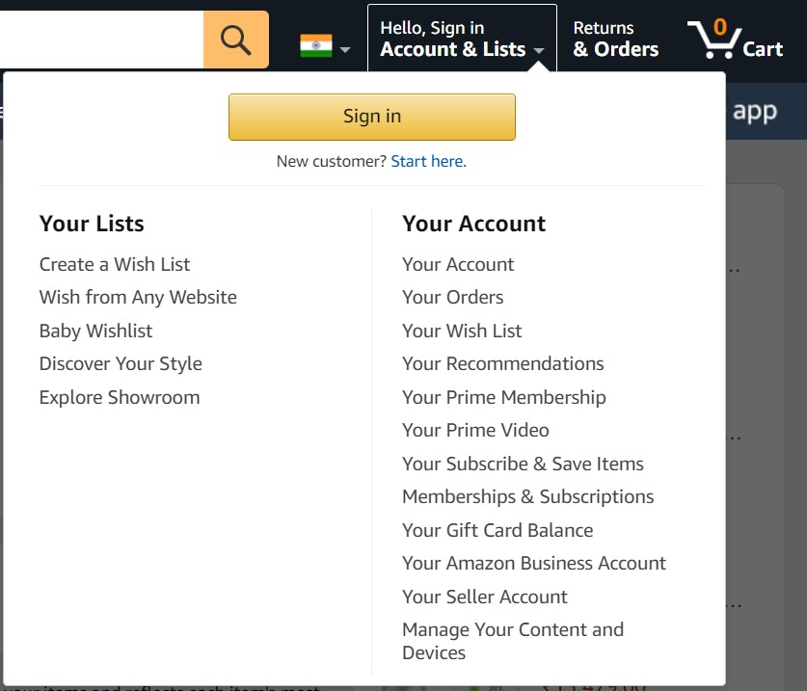

* FOOTER – (Get to know us , Connect with us, Make money with us, Let us help you)

**Product Page:** It shows description about the selected product.

It also as

ADD TO CART and

BUY NOW option.

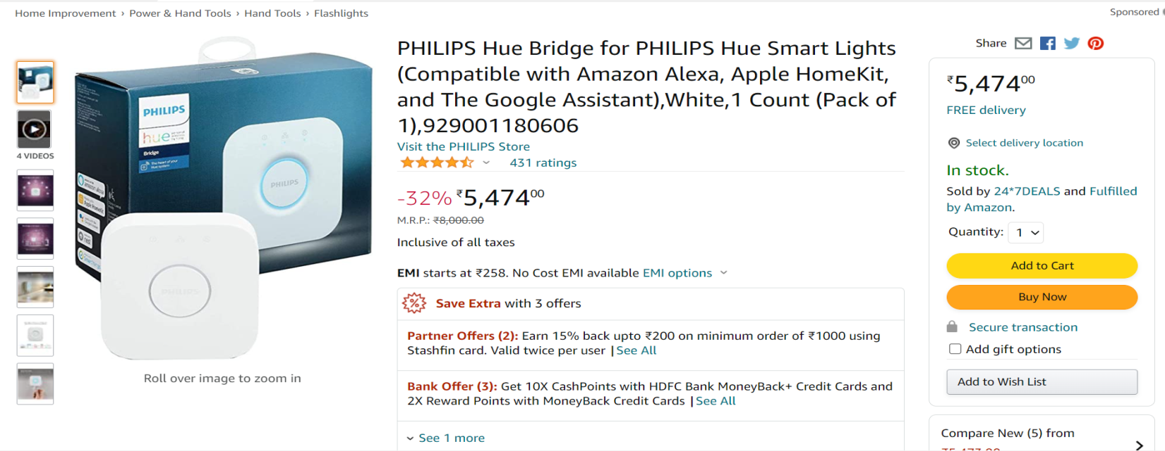

BUYING OPTION: It has different buying options

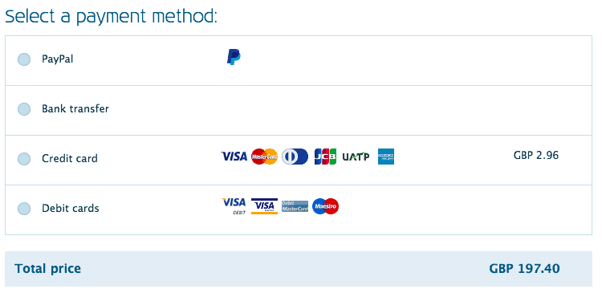

**Technologies used:**

* HTML
* CSS
* BOOT STRAP

**Coding software:**

* Visual studio
* Git hub

https://edureka-intership.github.io/assignment-1-manojmudhiraj/